(Your Logo Here)

**Free Onsite**

**Ultrasound Body Fat Testing!**

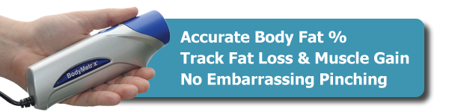

Body composition is more than skin deep, and sometimes percentages are not enough. The BodyMetrix System is the same professional-grade ultrasound technology used by elite athletes and trainers. Now you can see actual fat loss and muscle gain and assess targeted areas.

With BodyMetrix seeing is believing!

**Find out how (Your Business Here) can help you meet your fitness goals and how you can start to live a healthier life.**

Courtesy of (Your Business Here)

(Your Address Here)

(Your Contact Info Here)